##### JAMIE 4.3 SMALL IN LAMBSKIN

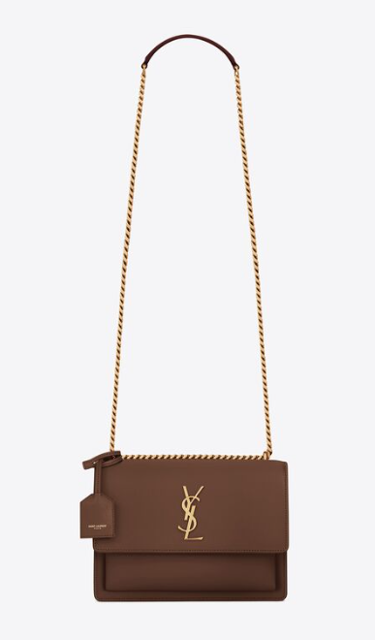  
The "Jamie 4.3 Small" is likely a handbag design from a specific brand or designer, and "lambskin" refers to the material used in its construction. Without additional context, it's challenging to provide specific information about this bag. However, if you have more details about the brand or designer associated with the Jamie 4.3 Small bag, I can offer more tailored assistance. Alternatively, you can provide more information about the bag's features or characteristics you're interested in, and I can provide general advice based on that.